## GIT with examples for testing Kafka app

## Pure and working Kafka producer/consumer filter

1. Install Kafka server and zookeeper by youTube **[lesson A](https://youtu.be/jY5fzVCkABg)**
2. Create consumer python app by youTube **[lesson B](https://youtu.be/7n1zlkPwUSQ)**
3. Create producer python app by youTube **[lesson C](https://youtu.be/Q4XA5nUpLeo)**
4. Upload GIT :
5. Execute a command using your parameters for filtering and terminating the filtering

***python .\consumer.py --opt1='MS' --topic='test'***

1. Run Kafka by CMD, from the folder where Kafka is located on your machine
   1. Run Zookeeper server >>
      1. $ .\bin\windows\zookeeper-server-start.bat .\config\zookeeper.properties
   2. Run Kafka server >>
      1. .\bin\windows\kafka-server-start.bat .\config\server.properties

## Run Kafka by CMD

Kafka server >>

$ .\bin\windows\kafka-server-start.bat .\config\server.properties

Zookeeper server >>

$ .\bin\windows\zookeeper-server-start.bat .\config\zookeeper.properties

## Run Kafka by docker-compose file

* ***[youTube tutorial](https://www.youtube.com/watch?v=8ZTTcAWMIAE&t=31s) - “Run Kafka by docker-compose file”***
* Here is an original tutorial by [the Confluent team](https://docs.confluent.io/platform/current/quickstart/ce-docker-quickstart.html#ce-docker-quickstart)

Where is a Kafka docker image?

It’s here >>> on the docker hub, confluentinc/cp-kafka [page](https://hub.docker.com/r/confluentinc/cp-kafka/)

On the [page](https://docs.confluent.io/platform/current/quickstart/ce-docker-quickstart.html#ce-docker-quickstart), to download or copy the contents of the [Confluent Platform all-in-one Docker Compose file](https://github.com/confluentinc/cp-all-in-one/tree/7.0.1-post/cp-all-in-one/docker-compose.yml) , edit it and run by command

In case when you want to use just **[zookeeper](https://zookeeper.apache.org/)**+ configured **[broker](https://kafka.apache.org/documentation/#brokerconfigs)** + configured **[control-center](https://docs.confluent.io/platform/current/control-center/index.html#:~:text=Confluent%20Control%20Center%20is%20a,develop%20and%20run%20ksqlDB%20queries.)** here is a working example of YAML file:

***docker-compose.yml***

|  |
| --- |
| ---  version: '2'  services:  zookeeper:  image: confluentinc/cp-zookeeper:7.0.1  hostname: zookeeper  container_name: zookeeper  ports:  - "2181:2181"  environment:  ZOOKEEPER_CLIENT_PORT: 2181  ZOOKEEPER_TICK_TIME: 2000  broker:  image: confluentinc/cp-server:7.0.1  hostname: broker  container_name: broker  depends_on:  - zookeeper  ports:  - "9092:9092"  - "9101:9101"  environment:  KAFKA_BROKER_ID: 1  KAFKA_ZOOKEEPER_CONNECT: 'zookeeper:2181'  KAFKA_LISTENER_SECURITY_PROTOCOL_MAP: PLAINTEXT:PLAINTEXT,PLAINTEXT_HOST:PLAINTEXT  KAFKA_ADVERTISED_LISTENERS: PLAINTEXT://broker:29092,PLAINTEXT_HOST://localhost:9092  KAFKA_METRIC_REPORTERS: io.confluent.metrics.reporter.ConfluentMetricsReporter  KAFKA_OFFSETS_TOPIC_REPLICATION_FACTOR: 1  KAFKA_GROUP_INITIAL_REBALANCE_DELAY_MS: 0  KAFKA_CONFLUENT_LICENSE_TOPIC_REPLICATION_FACTOR: 1  KAFKA_CONFLUENT_BALANCER_TOPIC_REPLICATION_FACTOR: 1  KAFKA_TRANSACTION_STATE_LOG_MIN_ISR: 1  KAFKA_TRANSACTION_STATE_LOG_REPLICATION_FACTOR: 1  KAFKA_JMX_PORT: 9101  KAFKA_JMX_HOSTNAME: localhost  KAFKA_CONFLUENT_SCHEMA_REGISTRY_URL: http://schema-registry:8081  CONFLUENT_METRICS_REPORTER_BOOTSTRAP_SERVERS: broker:29092  CONFLUENT_METRICS_REPORTER_TOPIC_REPLICAS: 1  CONFLUENT_METRICS_ENABLE: 'true'  CONFLUENT_SUPPORT_CUSTOMER_ID: 'anonymous'  control-center:  image: confluentinc/cp-enterprise-control-center:7.0.1  hostname: control-center  container_name: control-center  depends_on:  - broker  ports:  - "9021:9021"  environment:  CONTROL_CENTER_BOOTSTRAP_SERVERS: 'broker:29092'  CONTROL_CENTER_REPLICATION_FACTOR: 1  CONTROL_CENTER_INTERNAL_TOPICS_PARTITIONS: 1  CONTROL_CENTER_MONITORING_INTERCEPTOR_TOPIC_PARTITIONS: 1  CONFLUENT_METRICS_TOPIC_REPLICATION: 1  PORT: 9021 |

Kafka run is happening by command from the command line, from the folder where is Kafka located:

***$ docker-compose -f "docker-compose.yml" up***

.

When Kafka is up and running, you will see the successful logs.

Then you can open the “control center on the ***localhost:9021***

## Kafka (local installation)

#### [Article-1 - How to Install and Run Apache Kafka on Windows? - GeeksforGeeks](https://www.geeksforgeeks.org/how-to-install-and-run-apache-kafka-on-windows/)

#### [Article-2 - Install Apache Kafka on Windows](https://www.goavega.com/install-apache-kafka-on-windows/)

#### [YouTube - How to Install Apache Kafka on Windows](https://youtu.be/EUzH9khPYgs)

##### Upload Kafka archive from the web site: <https://kafka.apache.org/downloads>

##### Update ***zookeeper*** and ***server properties*** config files

* + 1. Edit zookeeper.properties file and modify line with ***dataDir*** according to your preferences.

In my case, it’s

***dataDir=D:/devSide/kafka/data/zookeeper***

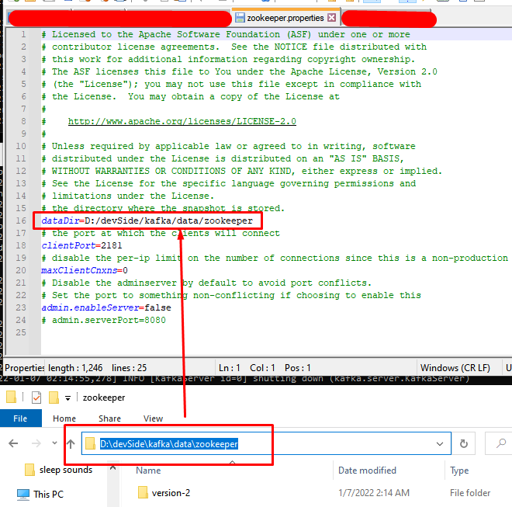

* 1. and ***server.properties*** config files.   
     Be careful with a path to your logs !!!!

In my case, it’s

***log.dirs=D:/devSide/kafka/data/kafka/logs***

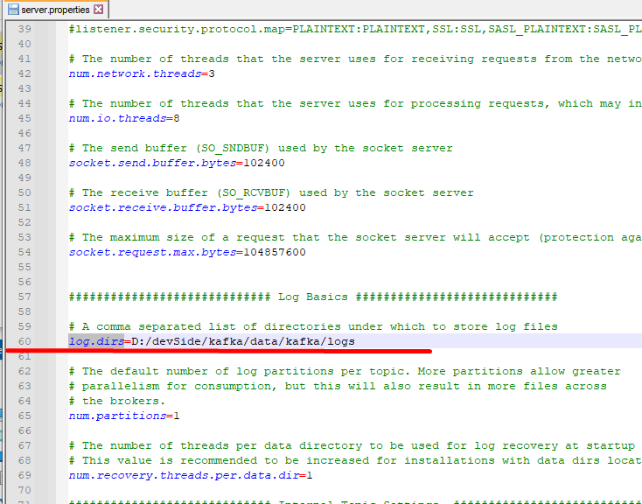

##### Run **zookeeper** by command:

***$ {kafka_folder_location}.\bin\windows\zookeeper-server-start.bat .\config\zookeeper.properties***

You should see in the terminal something like this

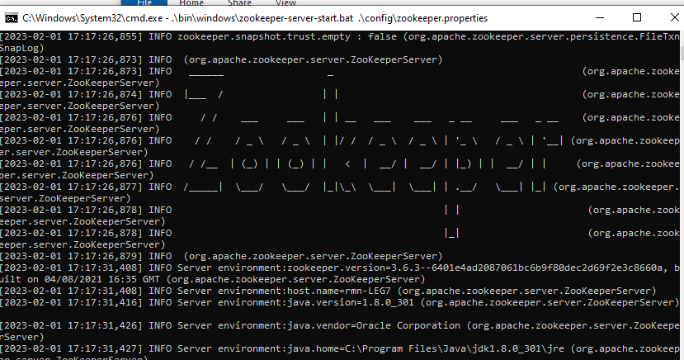

##### Run **Kafka server** by command:

**$ {kafka_folder_location}.\bin\windows\kafka-server-start.bat .\config\server.properties**

##### Create a topic by command:

**$ .\bin\windows\kafka-topics.bat --create --bootstrap-server localhost:2181 --replication-factor 1 --partitions 1 --topic TestTopic**

where ***TestTopic*** is the name of your topic.

# F.A.Q

## How to fix “**INFO ZooKeeper audit is disabled.**”

Some information is **[here](https://programmerah.com/error-in-starting-zookeeper-in-windows-zookeeper-audit-is-disabled-31066/)**

or ***change zookeeper.properties file by adding admin.enable = true***

## Errors.NoBrokersAvailable()

Please upload

## Kafka | commands for windows

GIT article link [HERE](https://stackoverflow.com/questions/53428903/zookeeper-is-not-a-recognized-option-when-executing-kafka-console-consumer-sh)

### To start zookeeper

C:\kafka-2.12>.\bin\windows\zookeeper-server-start.bat .\config\server.properties

### To start Kafka Broker

C:\kafka-2.12>.\bin\windows\kafka-server-start.bat .\config\server.properties

### To Create topic

C:\kafka-2.12\bin\windows>kafka-topics.bat --create --zookeeper localhost:2181 --replication-factor 1 --partitions 1 --topic test

### Start Producer

C:\kafka-2.12\bin\windows>kafka-console-producer.bat --broker-list localhost:9092 --topic test

### To create consumer

C:\kafka-2.12\bin\windows>kafka-console-consumer.bat --bootstrap-server localhost:9092 --topic test --from-beginning

### Topic creation With multi partition with replication factor 1

C:\kafka-2.12\bin\windows>kafka-topics --zookeeper localhost:2181 --topic first_topic --create --partitions 3 --replication-factor 1

### To get the list of topic created in system

C:\kafka-2.12\bin\windows>kafka-topics --zookeeper localhost:2181 --list

### To get the description of the topic created in system

C:\kafka-2.12\bin\windows>kafka-topics.bat --describe --zookeeper localhost:2181 --topic test

### To delete topic test created in system

C:\kafka-2.12\bin\windows>kafka-run-class.bat kafka.admin.TopicCommand --delete --topic test --zookeeper localhost:2181

### To read message from beginning of topic test created in system(version>2.0)

$ \bin\windows>kafka-console-consumer.bat --bootstrap-server localhost:9092 --topic test --from-beginning

kafka-console-consumer.bat --bootstrap-server localhost:9092 --topic register_user --from-beginning

## CMAK (Cluster Manager for Apache Kafka)

CMAK | Linux installation guide (GIT)

[LINK-1](https://github.com/yahoo/CMAK#cmak-cluster-manager-for-apache-kafka-previously-known-as-kafka-manager)

CMAK , v.2.0.0.2

[Instalation guide link -1](https://programmer.help/blogs/install-deployment-kafka-manager-2.0.0.2-under-windows.html)